Lookup Transformation:

Create Lookup Transformation----Redirect row to no match output:  
  
Source---Flat file----Destination---SQL Table.

**Flat file source**

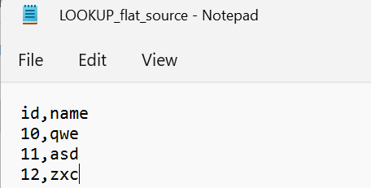

**OLE DB Destination**

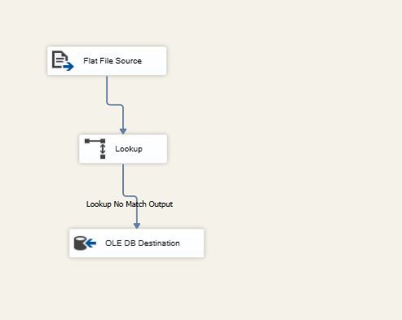

**Destination after execution**

